Integrated Research Application System (IRAS)

Guidance on preparing an application to MHRA Medicines for a Clinical Trial Authorisation using IRAS

Clinical trial authorisation (CTA) is required for any clinical trial of an investigational medicinal product (CTIMP) to be conducted in the UK. The standard application for CTA is the European Commission application form available from the EudraCT website at http://eudract.emea.europa.eu.

The whole of the EudraCT dataset is available in IRAS. Applicants can choose to complete the EudraCT dataset completely in IRAS. Alternatively, sponsors may choose to use the EudraCT website to make their application to MHRA Medicines. If the latter option is chosen, the information on the IMP(s) must be imported into IRAS to form part of the REC and R&D applications, or entered separately in IRAS.

If you want to prepare your application to MHRA using IRAS please follow the instructions in section 1.

If you have prepared your application to MHRA in EudraCT and only want to import information about IMPs for the REC and R&D applications please follow the instructions in section 2.

If you have prepared your application to MHRA in EudraCT and want to import ALL of the information into IRAS please follow the instructions in section 3.

If you have prepared your application to MHRA in EudraCT and will not be importing any information into IRAS please follow the instructions in section 4.

If you have prepared your application to MHRA in EudraCT and now want to use IRAS to prepare substantial amendments please follow the instructions in section 5.

Completing a EudraCT application form in IRAS

You will need to obtain a EudraCT number for this application. Once a EudraCT number has been obtained it is possible to use IRAS to complete the whole EudraCT dataset and to save the application in the format required for submission to MHRA.

For detailed submission guidance, please see the MHRA website.

There is no need to export the data from IRAS to the EudraCT website in order to make an application to MHRA.

Unlike the EudraCT website, there is no need to save the XML file to your computer whilst preparing your application. As with all other parts of IRAS, your data is saved to your account in IRAS. This means you can access your application through your IRAS account from any computer and do not have to worry about losing your data.

  - Obtaining a EudraCT number

You will need to obtain a EudraCT number for this application. You will need to request a Security Code and then obtain a EudraCT number. Once you have obtained this, there is no need to complete any further information on the EudraCT website as the remainder of your application can be made in IRAS.

To obtain a security code, use the following sequence:
- Go to the EudraCT website at https://eudract.emea.europa.eu/eudract/index.do
- From the EudraCT Welcome Screen take the link: ‘Apply for Security Code’.
- Complete the fields, both of which are mandatory. The e-mail address should be accurate so that the e-mail containing the security code is sent to the correct recipient.
- When the fields have been correctly completed press the “Get Security Code” link and a confirmation screen will appear. The e-mail will arrive shortly afterwards (depending on network traffic etc.).
- Check the e-mail address printed on this confirmation screen to be sure that it does not contain any typing errors. If the e-mail address is incorrect then the e-mail cannot be delivered.
- At this point press ‘Continue’ to return to the EudraCT Welcome Screen. The e-mail that contains the security code is sent to the e-mail address used in the request form.
- Open the e-mail account used on the request from to find the e-mail. This will be from user: EudraCT@eudra.org and with the subject: Application for Security Code
- Open the message to obtain the security code.
- Keep the e-mail containing the security code for use in your request for a EudraCT number. The security code may be copied and pasted from the e-mail into the EudraCT number request form.

To obtain a EudraCT number:
- From the EudraCT Welcome Screen take the link: ‘Apply for EudraCT number’
- The requestor now completes all the mandatory fields which are marked with (*).
  - “Requestor’s organisation name”. Include the name of the organisation that the requestor works for in this field.
  - If the requestor is not making the request on behalf of an organisation, but on their own behalf, then the “Requestor’s organisation name” should be left blank. However, you should use the fields “Requestor’s organisation town/city” and “Requestor’s organisation country” to enter your own Town or City and Country respectively.
  - “Requestor’s organisation town/city(*)”. This is a mandatory field.
  - “Requestors organisation country (*)”. This is a mandatory field. Select the appropriate country from the drop-down list of all the countries of the world.
  - “Sponsor’s Protocol Code Number (*)”. This is the Protocol Code Number for the clinical trial that will be linked to the EudraCT number obtained from this request and is not generated by the system. If you are unsure what this value is, you should contact the Sponsor. It should be entered in the normal format used by the requestor’s organisation. This is a mandatory field.
Note: The sponsor’s Protocol Code Number field cannot contain blank spaces.
  - “Requestor name(*)”. Enter your name. This is a mandatory field.
  - “E-mail to which the EudraCT Number will be sent(*)”. Enter the e-mail address to which the EudraCT number should be sent. Any valid e-mail address is acceptable and need not be the requestor’s e-mail. This is a mandatory field.
  - “Enter the security code sent earlier (*)”. Enter the EudraCT security code obtained by using the ‘Get Security Code’ link. It may be found in the “Application for Security Code” e-mail you should have received. This security code must not have been used on another application and it should be used within 24 hours, or a new security code must be requested. This is a mandatory field.
  - “Is it anticipated that this EudraCT Number will be used for a Clinical Trial contained in a Paediatric Investigation Plan (PIP)? (*)” This is a mandatory field.
  - “Is it anticipated that this EudraCT number will be used for a Clinical Trial conducted in a third country (outside of the EU/EEA). (*)” This is a mandatory field.
Note: A third country is any country outside the European Economic Area (EEA). The EEA contains member states of the EU, plus Iceland, Liechtenstein and Norway.
  - “Please select the Member States where it is anticipated that the trial will be run”. This is not mandatory information (unless it relates to the above question), but completion will provide some advanced indication of likely Clinical Trial applications in each Member State. The Member States selected should be the best available information at the time the EudraCT number is requested. This might change, but if it does there is no requirement to notify any Member States of the changes.
- When the fields have been correctly completed you should press the “Get EudraCT Number” link and a confirmation screen appears. The e-mail will arrive shortly afterwards (depending on the speed of your local e-mail servers).
- Check the e-mail address printed on this confirmation screen to be sure that it does not contain any typing errors. If the e-mail address is incorrect then the e-mail cannot be delivered.
- At this point press “Continue” to return to the EudraCT Welcome Screen. The e-mail that contains the EudraCT number will be sent to the e-mail address used in the request form.
- Open this e-mail account to find the e-mail. This will be from user: EudraCT@eudra.org with the subject: Application for EudraCT Number
- Open the message to obtain the EudraCT Number.
- This e-mail also includes the Sponsor Protocol Code Number, you supplied previously for this request.
- Save this e-mail. It is the ‘Receipt of confirmation of EudraCT Number’ document and is one of the supporting documents that must be included in the request for the Clinical Trial.

  - Entering data in IRAS

Please note that the User Manual on the EudraCT website relates only to applications made through the EudraCT website. IRAS contains the relevant guidance for preparing an application in IRAS.

We recommend that you complete the integrated dataset as this will populate all the relevant forms for your project. Once you have entered all the data you can then select the MHRA Medicines (EudraCT application) form from the form list and follow the instructions on the submission tab to prepare your application for submission.

Alternatively, you can choose to complete the EudraCT application form separately by selecting the MHRA Medicines (EudraCT application) form and completing each of the sub-sections.

Please note that a duplicate subset of questions needs to be completed for each product to be used in the trial. Once the set of questions is completed for one product you will be instructed to return to the beginning of the set of questions to enter the details of every other product. This set of questions is listed against the code number of each product in the navigation part of the screen.

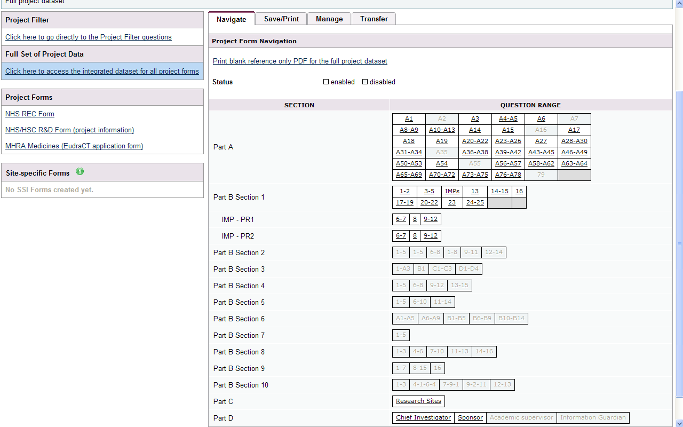

  - Submitting the EudraCT application

You must provide both an XML file and a pdf file of your application. Please select the EudraCT form and follow the instructions on the submission tab.

Please note that the printout of the form contains all the fields in the official EudraCT application, including sections for use in countries where all of the form is also used for REC applications. The printout therefore includes some sections, e.g. C2, that are not required for the application to the Competent Authority. These sections are not visible when completing the application on screen and should be left blank in the pdf copy.

In EudraCT every field is given a number. However, in IRAS only the questions are numbered. The numbers of intervening fields and options are not included. This is so the screen is not cluttered with question numbers. The pdf file will, therefore, appear to have some question numbers missing but these are simply the numbers for the fields and options applicable to that question.

Importing IMP information from EudraCT to IRAS
You can complete a EudraCT form through the EudraCT website first and import IMP information to IRAS. This option may apply if other colleagues are responsible for preparing the application to the Competent Authority.

To import IMP data only from EudraCT into an existing IRAS project:
- Select the project and make sure that MHRA Medicines has been selected in question 4 of the project filter
- Select the MHRA Medicines (EudraCT application) form from the list of forms on the main navigation screen
- Follow the instructions under the Import/ Export tab.
- Make sure you select the option for ‘IMPs Import’

Once the data is imported, Part B Section 1 of the integrated dataset in IRAS will then be populated with the information already completed in EudraCT that is needed by other review bodies. This information on the IMP(s) is included in the REC and R&D forms. As you have already prepared your EudraCT application you do NOT need to complete any other questions in Part B Section 1 other than the IMP information that has been imported from EudraCT.

Please check your imported data for accuracy.

To import IMP data only from EudraCT into a new IRAS project:
- Log into IRAS
- At the top of the screen select the ‘Import’ button to import IRAS or
EudraCT Form XML
- Follow the instructions on screen
- Make sure you select the option for ‘IMPs Import’

As you have already prepared your application in EudraCT you do not need to select the option for MHRA Medicines in question 4 of the project filter (but you must still select the correct study type in question 2). Please make sure you complete the Project Filter before proceeding with entering any other data.

Please check your imported data for accuracy.

Importing all the information from EudraCT into IRAS

If you or a colleague have completed an application in EudraCT, you can import all the information from EudraCT into IRAS. This option populates all the fields in Parts A and B that are included in the MHRA application. If you use this option with an existing project, please note that this will overwrite any existing data in the project in IRAS.

Please check your imported data for accuracy.

To import all data from EudraCT into an existing IRAS project:
- Select the project and make sure that MHRA Medicines has been selected in question 4 of the project filter
- Select the MHRA Medicines (EudraCT application) form from the list of forms on the main navigation screen
- Follow the instructions under the Import/ Export tab.
- Make sure you select the option for ‘Full Import’
- Be aware that existing data in Parts A and B will be over-written

To import all data from EudraCT into a new IRAS project:
- Log into IRAS
- At the top of the screen select the ‘Import’ button to import IRAS or
EudraCT Form XML
- Follow the instructions on screen
- Make sure you select the option for ‘Full Import’

As you have already prepared your application in EudraCT you do not need to select the option for MHRA Medicines in question 4 of the project filter (but you must still select the correct study type in question 2). Please make sure you complete the Project Filter before proceeding with entering any other data.

Using IRAS without importing data from EudraCT

If a colleague has prepared the application to MHRA in EudraCT, you do not need to have the XML data from EudraCT in order to complete your other applications in IRAS. You can simply enter the information about the IMPs that is required for the REC and R&D Forms directly into IRAS.

Select the correct study type in question 2 of the project filter, but do not select MHRA Medicines in question 4 of the project filter as you will not be using IRAS for this application. The integrated dataset will now only contain the questions in Part B Section 1 that are enabled within the REC or R&D form.

Please note that applicants are expected to ensure that the data submitted to MHRA is consistent with that submitted to other review bodies.

Notifying substantial amendments

Substantial amendments to CTIMPs must be notified using the European Commission form. This document is available from the EudraCT website or can be downloaded from the Amendment tab in IRAS. The form must be accompanied by an amended EudraCT application.

Submitting an amended EudraCT application using IRAS
If your application was prepared in IRAS, you can edit the application and follow the instructions under the Submission tab to create an amended form.

Importing data from EudraCT to prepare an amended application using IRAS
You can import the full EudraCT dataset into your existing project in IRAS following the instructions in Section 3 above. The imported data can then be edited in IRAS as usual. Please note that using this option will overwrite any existing data in IRAS.

Exporting data from IRAS to EudraCT

You can complete the information in IRAS and export all the information prepared in IRAS to EudraCT if you wish. Please note that this is not necessary in order to make an application to MHRA as you can create the appropriate XML file and printout from the Submission tab. This option may be useful to transfer data to colleagues preparing applications to other Competent Authorities.

To export information from IRAS, select the MHRA Medicines (EudraCT application) form from the list of forms and follow the instructions under the Import/ Export tab.

